estec
European Space Research
and Technology Centre
Keplerlaan 1
2201 AZ Noordwijk
The Netherlands
T +31 (0)71 565 6565
F +31 (0)71 565 6040
www.esa.int
Progress Report / Status Report

Monthly Report Intern Matteo De Benedetti - December 2019

Approval
Title Monthly Report Intern Matteo De Benedetti - December 2019
Issue Number 0 | Revision Number 0
Author Matteo De Benedetti | Date 02/01/2020
Approved By | Date of Approval
Martin Azkarate

Change Log
Reason for change | Issue Nr. | Revision Number | Date
Creation of Document | 1 |  | 02/01/2020

Change Record
Issue Number 0 | Revision Number 0
Reason for change | Date | Pages | Paragraph(s)
Creation of Document | 02/01/2020 | All | All

Distribution
Name/Organisational Unit
Martin Azkarate, TEC-MMA, ESA-ESTEC
Mario Innocenti, Robotics and Automation Engineering, University of Pisa

Table of contents:
1 Introduction 4
1.1 Scope of the Document 4

2 Visual odometry frequency 4
2.1 Effects of the VO Frequency 4
2.2 Control of the VO Frequency 6

3 vo frequency Tests 7
3.1 Different VO frequencies at high and low speed 7
3.2 Different IFDs at high and low speed 10
3.3 Small IFDs at high and low speed 13

4 Visual odometry on the Navcam 16
4.1 NavCam 16

5 navcam tests 17
5.1 Different Pitch values 17
5.2 Comparison between LocCam and NavCam at fixed pitch 20
5.3 Comparison between LocCam and NavCam on a complex trajectory 22

6 spartan vo integration 25

7 References 26
7.1 Reference Documents 26
7.2 List of Acronyms 26
7.3 Table of Figures 26

Introduction

Scope of the Document
This document reports the work done by the author, Matteo De Benedetti, during his fourth month, from the 2nd of December to the 20th of December, as an intern in the Planetary Robotics Lab (PRL) at the European Space Research and Technology Centre (ESTEC).

Visual odometry frequency

Effects of the VO Frequency
The VO frequency is influenced by two processes: the image acquisition and the SpartanVO task.
Since the VO estimate is computed based on two pairs of stereo images, the VO frequency is a direct consequence of the camera fps, but it is also affected by the SpartanVO task period. If the task’s period is longer than the time between two frames, then a stereo pair will be skipped and the VO will be computed based on the next frames, resulting in a VO frequency that is a multiple of the camera fps.

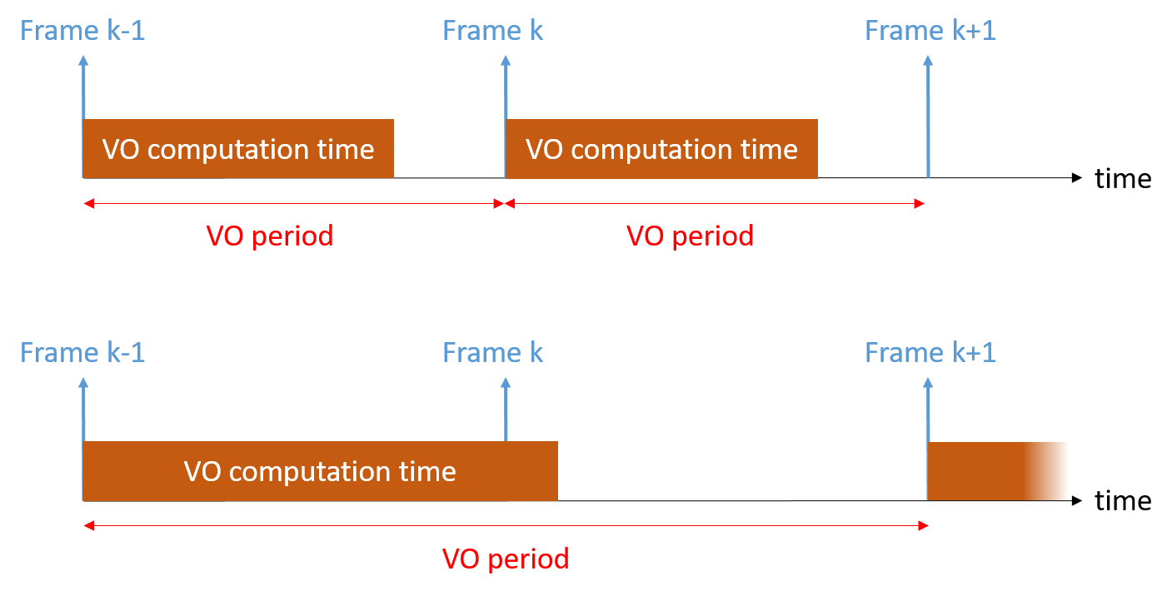
Figure 1: VO frequency from camera fps and VO computation time

The VO frequency has a great influence in the VO process, therefore two concept were introduced.

The Inter-Frame Distance (IFD), expressed in meters, is defined as the spatial distance in the world between the points of acquisition of two frames. The IFD also depends on the rover’s speed and it is computed simply by multiplying the VO period with the rover’s speed.

The Image Overlap Percentage (IOP) is the percentage of the area of an image that is common between two frames at different time steps.
It is conceptually similar to the IFD and also more general, since it also depends on the camera placement on the rover (height and orientation), but it loses information about the physical distance between frames.

The computation of the IOP is more complicated and an approximated model has been defined.
Assuming the rover travels on perfectly flat ground with exactly the same motion as commanded, meaning no vibrations from rocks and slip of the terrain, the problem becomes purely geometrical, as shown in the following figure.

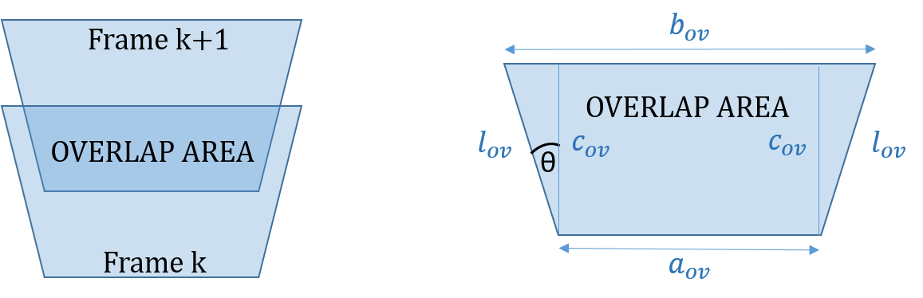
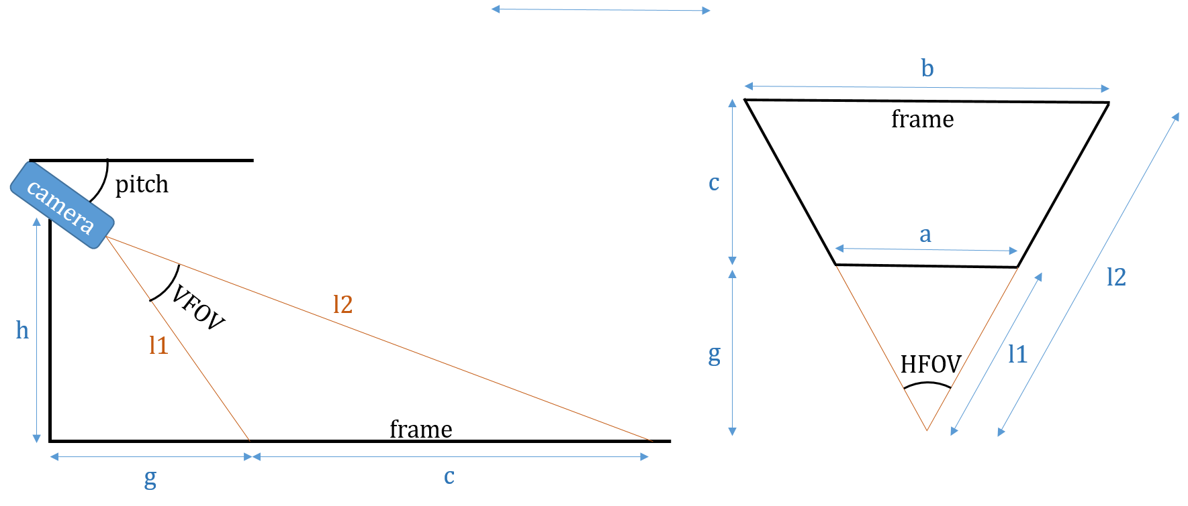
Figure 2: Image Overlap Percentage scheme

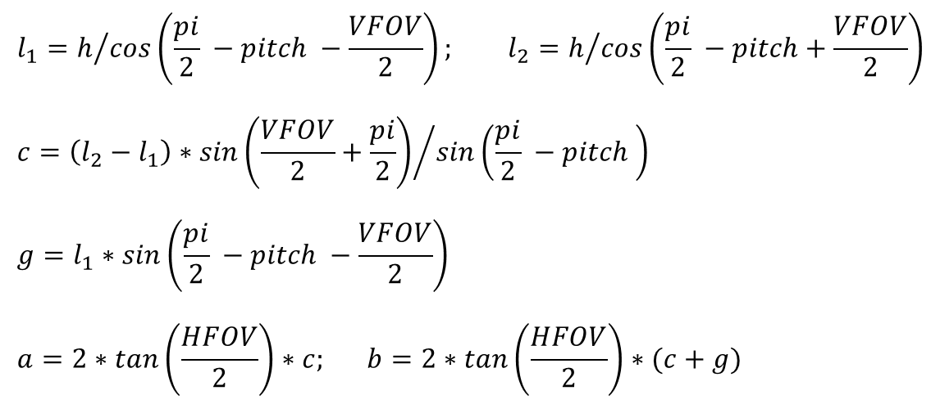
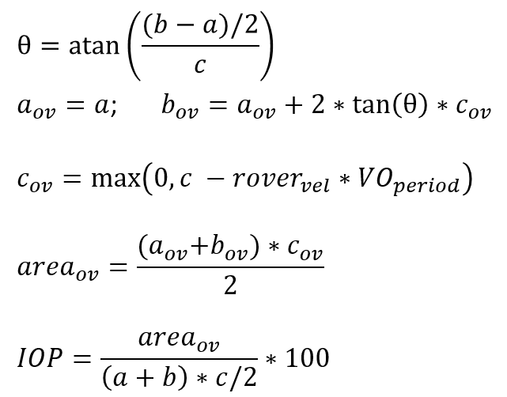

Control of the VO Frequency
Controlling the VO frequency actually means controlling the frequency of the images that are used by the VO to estimate the motion.
The camera on the rover can only be controlled with a specific set of framerates: 1.875, 3.75, 7.5, 15, and 30.
Note that since it is a stereo camera, the actual framerate of the left and right channel will be half of it.
The VO computation time cannot be controlled, so to get an idea of it, the computation time is measured at every VO step and logged in an output port. 10 different tests (with different velocities, trajectories, and ambient light, to try to cover as much as possible of the input space) have been analyzed and the results are the following:

Figure 3: SpartanVO computation time distribution

- Average Computation Time: 0.3192 seconds
- Standard Deviation: 0.0975 seconds
- Worst-case Observed Execution Time (WOET): 0.7566 seconds
Ideally the WCET (Worst Case Execution Time) would be used, but this is computed analytically by looking at the worst case flowchart and the specific instructions that are executed in a task step. This is impossible at the current state since the rover is not running a Real Time OS and therefore there could, and for sure will, be preemptions from other tasks.
- Best Observed Execution Time (BOET): 0.1729
This means that, while it would be interesting to investigate even slower framerates, already the second slowest setting of 3.75 fps will start skipping frames.
To be able to achieve any desired and also slower framerate, the solution that has been implemented is to run the camera at the highest framerate (30) and then the VO task has been slightly modified to skip frames in order to achieve a desired period.
The following plots show that this strategy is able to obtain a desired framerate (lower than 30) with an acceptable precision and few samples that are unsynchronized (the y axis shows the time from the previous sample).

Figure 4: Performances of the frequency control

vo frequency Tests

Different VO frequencies at high and low speed
The first set of tests investigated the effect of decreasing VO frequencies (meaning also increasing IFDs) at 0.07 m/s for a 5m traverse.

Test1: VO frequency = 2.5 [Hz], IFD = 0.028 [m]
Test2: VO frequency = 1.0 [Hz], IFD = 0.07 [m]
Test3: VO frequency = 0.5 [Hz], IFD = 0.14 [m]
Test4: VO frequency = 0.33 [Hz], IFD = 0.21 [m]
Test5: VO frequency = 0.25 [Hz], IFD = 0.28 [m]
Test6: VO frequency = 0.20 [Hz], IFD = 0.35 [m]
Figure 5: Test with decreasing VO frequency at high speed

The second set of tests investigated the effect of decreasing VO frequencies (meaning also increasing IFDs) at 0.02 m/s for a 5m traverse.

Test1: VO frequency = 2.5 [Hz], IFD = 0.008 [m]
Test2: VO frequency = 1.0 [Hz], IFD = 0.02 [m]
Test3: VO frequency = 0.5 [Hz], IFD = 0.04 [m]
Test4: VO frequency = 0.33 [Hz], IFD = 0.06 [m]
Test5: VO frequency = 0.25 [Hz], IFD = 0.08 [m]
Test6: VO frequency = 0.20 [Hz], IFD = 0.1 [m]

Figure 6: Tests with decreasing VO frequency at low speed, position error

Figure 7: Tests with decreasing VO frequency at low speed, orientation error

The results show that slower frequency seems to not affect the slope of the error curves, but they are affected by sudden jumps (which only appear in the high velocity tests), as if a higher frequency, combined with the high speed, amplifies error jumps that are considerably smaller at faster frequency and lower speeds.

Different IFDs at high and low speed
As seen in section 3.1, the same VO frequency generates a different IFD according to the rover’s speed.
Therefore the next two tests sets investigated the VO performances maintaining the same IFDs in high and low speed.

In the sequence at 0.07 m/s the VO starts losing accuracy when the IFD gets bigger than 0.3 meters and IOP smaller than ~75%, while for smaller values of IFD and bigger IOP it performs well and with no significant variations.

Figure 8: Tests with increasing IFDs at high speed

Also in the sequence at 0.02 m/s the VO starts losing accuracy when the IFD gets bigger than 0.3 meters and IOP of ~75%, while for smaller values of IFD and bigger IOP it performs well and with no significant variations.

Figure 9: Tests with increasing IFDs at low speed
To see if the IFD and IOP have an effect on the performances that depends of the speed, the results for the same IFD and IOP in high and low speed have been plotted together.

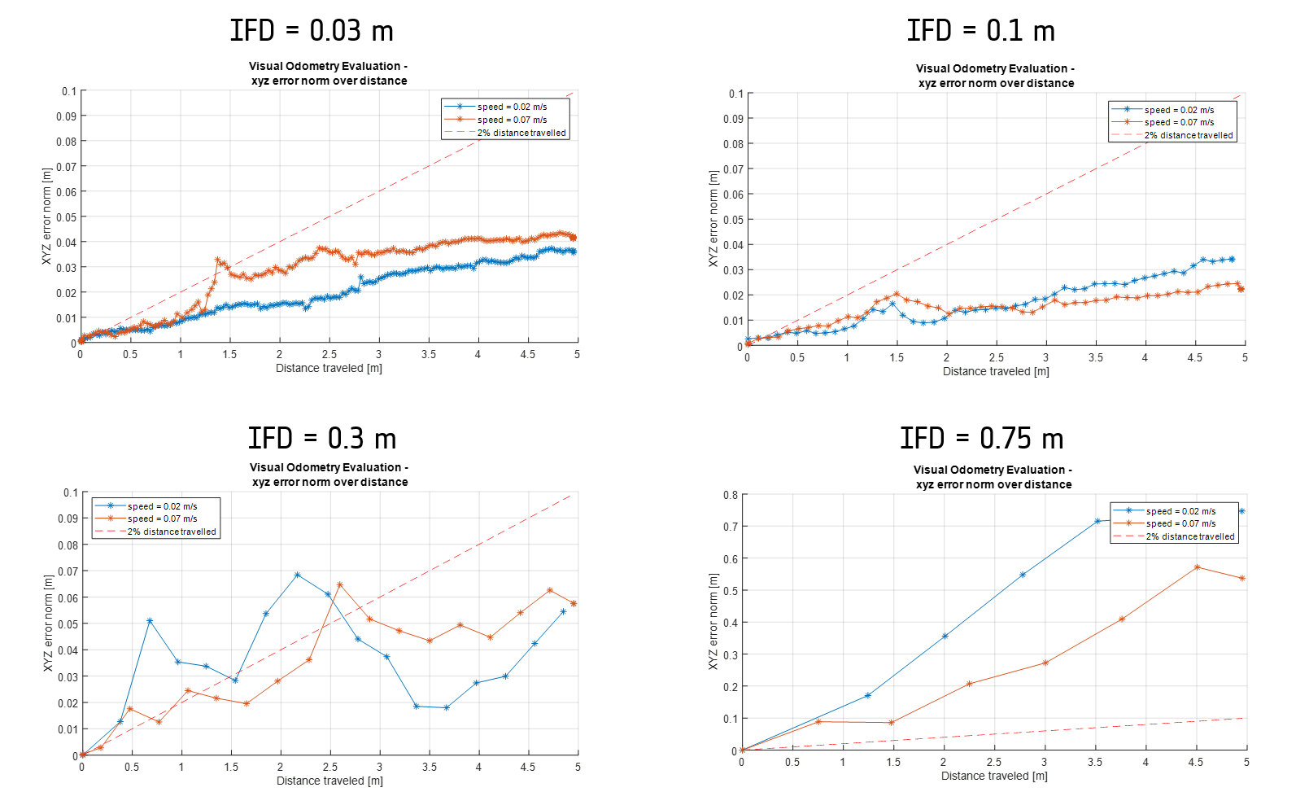
Figure 10: High and low speed at different IFDs

The plots clearly show that the VO performances are affected by the IFD and IOP in a very similar way, whether the rover is moving at a high or low speed.

Small IFDs at high and low speed
In section 3.2 it was found that for IFD>0.3m and IOP<75% the VO started to lose accuracy.
In the next tests it was investigated if a similar behaviour also occurs for high IOPs and small IFDs.

A small IFD (and therefore large IOP) leads to a problem where a very small difference in position in the temporal matches, that can be achieved running the VO at a high frequency and moving the rover slowly, leads to inaccuracies in the motion estimation.
This problem is very well known in VO and is usually counteracted using a technique called keyframes selection [RD04], [RD05] which consists in skipping frames until the uncertainty of the matches, or many other possible metrics, like the IFD or IOP, decreases under a certain threshold.

The same high speed sequence has been used and the focus was on small IFD values.
The results did suggest that an IFD smaller than 0.1m (and therefore IOP higher than 90%) leads to a small decrease in performances.

Figure 11: Small IFDs at high speed
In the low speed tests the same appeared to happen, though the difference was considerably smaller, possibly thanks to the lower speed of the traverse.

Figure 12: Small IFDs at low speed

Visual odometry on the Navcam

NavCam
The Navigation Camera (NavCam) is the same model as the LocCam (Bumblebee BB2) but it is located on top of the mast on a motorized Pan and Tilt Unit (PTU), as shown in the drawing.
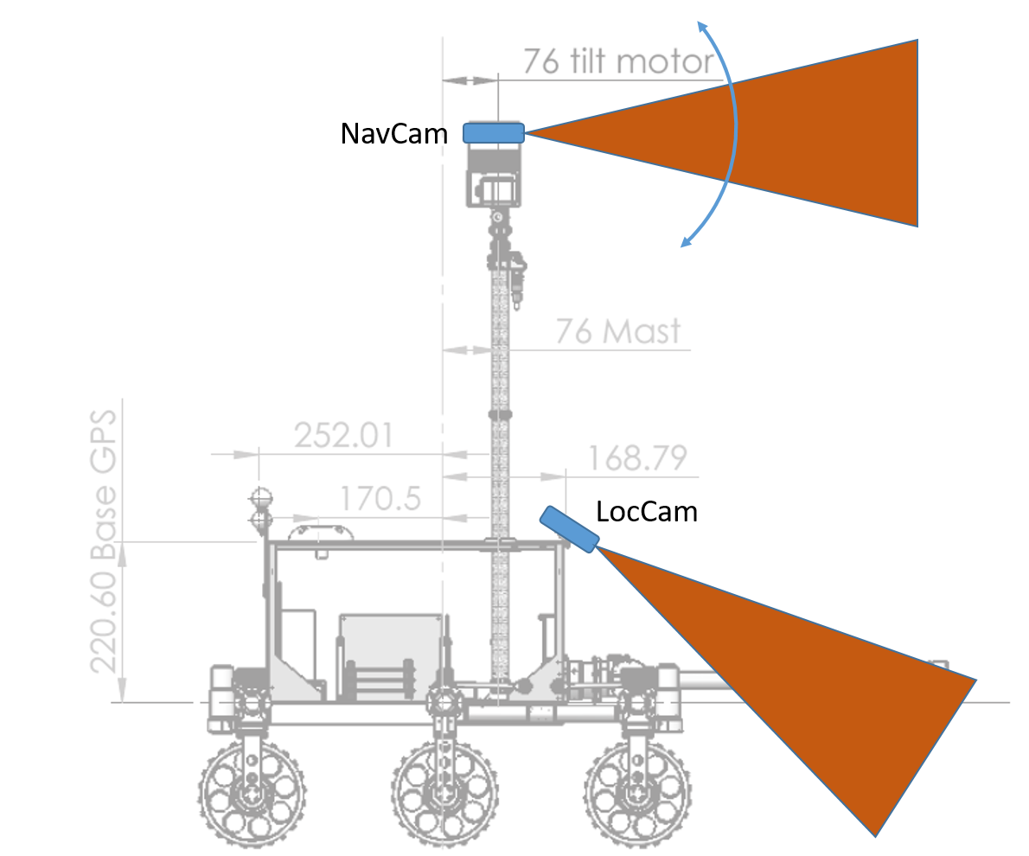
Figure 13: NavCam on the ExoTeR rover
To use the NavCam in the SpartanVO pipeline developed so far, a small number of adjustments has been necessary, such as importing the new parameters, connecting the appropriate tasks, adding the possibility of controlling the PTU angles in the motion_generator component, setting up the transform from the ExoTeR body to the camera on the PTU and resetting the zero of the PTU motors.

After the SpartanVO was compatible with the NavCam, the same procedure used with the LocCam to refine the body-camera transform was used, obtaining a small increase in the position estimate accuracy.

Figure 14: Body to NavCam transform refinement

The major difference between the NavCam and the LocCam is the possibility to change the pitch of the camera, while to LocCam was fixed on the rover’s body with a pitch of 30 degrees.

Changing the pitch of the camera has the effect of decoupling the IFD and IOP, since different pitch values will still lead to the same IFD (which is only function of the rover’s speed and VO frequency) but will now mean different IOP.

For example, with the same speed and VO frequency, a camera pointed to the ground below the rover (pitch=90 deg) will lead to a considerably smaller IOP than a camera pointed forward, like in the case of the LocCam.

navcam tests

Different Pitch values
Using a 5 m sequence at 0.07 m/s with VO frequency of 0.2 Hz and therefore IFD = 0.3 m, different pitch values were tested, leading to also different IOPs.

navcam pitch = 20deg – IOP = 99.99%
navcam pitch = 30deg – IOP = 89.5863%
navcam pitch = 40deg – IOP = 71.9826%
navcam pitch = 50deg – IOP = 53.3938%
loccam pitch = 30deg – IOP = 71.9826%

Figure 15: Different Pitch Values at low VO frequency

Another set of tests was run with the same conditions of the previous one, but with a higher VO frequency of 1 Hz, leading to a smaller IFD of 0.07m and larger IOPs.

navcam pitch = 20deg – IOP = 99.99%
navcam pitch = 30deg – IOP = 97.8717%
navcam pitch = 40deg – IOP = 93.8529%
navcam pitch = 50deg – IOP = 89.5461%
loccam pitch = 30deg – IOP = 94.0312%

Figure 16: Different Pitch Values at higher VO frequency
The last two sets of tests with the NavCam at different pitches, IOPs and VO frequency showed that the NavCam VO has generally worse performances than the LocCam VO and, while the LocCam is influenced only by the IOP since its mount is fixed to ExoTeR’s body, the NavCam did not appear to only be influenced by the IOP, but also by the camera pitch, since a pitch of 20 degrees led to a big loss in accuracy even at very high IOP.

The reason behind this could be that the camera pitch does not only affect the IOP, but also changes the depth of the features in the frames: a small pitch of 20 degrees means that most of the features are very far and there are not many close features coming from the ground, as opposed to the 30 degrees of the LocCam.

Comparison between LocCam and NavCam at fixed pitch
In the next two tests sets the pitch has been fixed to 37.7 degrees, a value that gave good results in the previous tests and allows to obtain the same IFDs and IOPs that were studied with the LocCam and gave both good (IFD = 0.1m and IOP = 93%) and bad (IFD = 0.3m and IOP = 85%) performances.

The following tests show the results for:
Speed=0.07m/s, NavCam pitch = 37.7 degrees, IOP=92.61%, IFD=0.1m, where the LocCam achieved a good accuracy.

Figure 17: Comparison between LocCam and NavCam with good IOP and IFD, position error
Figure 18: Comparison between LocCam and NavCam with good IOP and IFD, orientation error

The following tests show the results for:
Speed=0.07m/s, NavCam pitch = 37.7 degrees, IOP=78.68%, IFD=0.3m, where the LocCam’s accuracy started to degrade.

Figure 19: Comparison between LocCam and NavCam with bad IOP and IFD, position error
Figure 20: Comparison between LocCam and NavCam with bad IOP and IFD, orientation error

The last two sets of tests show that the NavCam VO maintained the same performances when changing the IFD and IOP through the VO frequency, while the LocCam VO showed better performances with lower IFD and higher IOP (IFD = 0.1m and IOP ~ 93%) with respect to higher IFD and lower IOP (IFD = 0.3m and IOP ~ 78%)

Comparison between LocCam and NavCam on a complex trajectory
A final comparison, using the best combination of parameters for both the LocCam and the NavCam, on a more complex L-shaped trajectory, has been executed.

Figure 21: Comparison between NavCam and LocCam on more complex trajectory

Figure 22: Comparison between NavCam and LocCam on more complex trajectory, position error
Figure 23: Comparison between NavCam and LocCam on more complex trajectory, orientation error

Considering all the tests run with the NavCam and this final comparison, the NavCam showed in general inferior performances compared to the LocCam.
This is believed could be caused by two possible reasons:
- The higher position of the camera does not allow close features to be used in the motion estimation, even with a high pitch, which will then lead to a very small IOP and the loss of far features and therefore low VO accuracy.
- The camera mounted on the PTU is considerably more sensible to vibrations of the mast when the rover moves, compared to the LocCam bracket which is better fixed to the ExoTeR body.

spartan vo integration
The integration of the SpartanVO library in the RoCK environment has been further improved adding the Stream Aligner to two of the tasks of the VO.

The Stream Aligner is used to align the inputs of a RoCK component based on their timestamp instead of the time of arrival. This is crucial when one of the signal arrives with a non-negligible delay due to the computation time required to compute it, which is exactly the case of the VO estimates.

The task that fuses the VO pose with the IMU readings was using the VO estimate combined with the last IMU measurement, which is the measurement obtained when the VO estimate is completed, not when the pictures used for the VO are acquired (between the 2 there is the VO step computation time).
Now, using the stream aligner, it aligns the timestamps of the signals of the VO and IMU.
With this addition a little improvement in the estimate has been achieved.

Figure 24: Stream Aligner improvements

The task which takes the final VO estimate and compares it with the GT from the Vicon System had the same problem, it would compute the difference between VO and GT using misaligned data.
This was previously fixed in post processing when the data was plotted in Matlab, and now it has been fixed with the stream aligner and also the task now allows to see the real error and other useful outputs (VO estimate in position and orientation, GT in position and orientation, distance travelled, error in percentage) directly at runtime.

References

Reference Documents
Reference | Document
[RD01] | ESA PRL GitHub, visodom branch, https://github.com/esa-prl/
[RD02] | Personal GitHub, https://github.com/MatteoDeBenedetti/ESA-Thesis
[RD03] | Viso2 Library, “Visual Odometry based on Stereo Image Sequences with RANSAC-based Outlier Rejection Scheme”, Bernd Kitt and Andreas Geiger and Henning Lategahn
[RD04] | D. Scaramuzza, F. Fraundorfer “Visual Odometry: Part I - The First 30 Years and Fundamentals”, IEEE Robotics and Automation Magazine, Volume 18, issue 4, 2011.
[RD05] | Fanfani, M., Bellavia, F. & Colombo, C. “Accurate keyframe selection and keypoint tracking for robust visual odometry”, Machine Vision and Applications (2016) 27: 833.

List of Acronyms
Acronym | Full description
ESA | European Space Agency
ESTEC | European Space Research and Technology Centre
VO | Visual Odometry
PRL | Planetary Robotics Laboratory
ExoTer | ExoMars Testing Rover
IOP | Image Overlap Percentage
IFD | Inter-Frame Distance
LocCam | Localization Camera
NavCam | Navigation Camera
PTU | Pan and Tilt Unit

Table of Figures
Figure 1: VO frequency from camera fps and VO computation time 4
Figure 2: Image Overlap Percentage scheme 5
Figure 3: SpartanVO computation time distribution 6
Figure 4: Performances of the frequency control 7
Figure 5: Test with decreasing VO frequency at high speed 8
Figure 6: Tests with decreasing VO frequency at low speed, position error 9
Figure 7: Tests with decreasing VO frequency at low speed, orientation error 10
Figure 8: Tests with increasing IFDs at high speed 11
Figure 9: Tests with increasing IFDs at low speed 12
Figure 10: High and low speed at different IFDs 13
Figure 11: Small IFDs at high speed 14
Figure 12: Small IFDs at low speed 15
Figure 13: NavCam on the ExoTeR rover 16
Figure 14: Body to NavCam transform refinement 17
Figure 15: Different Pitch Values at low VO frequency 18
Figure 16: Different Pitch Values at higher VO frequency 19
Figure 17: Comparison between LocCam and NavCam with good IOP and IFD, position error 20
Figure 18: Comparison between LocCam and NavCam with good IOP and IFD, orientation error 21
Figure 19: Comparison between LocCam and NavCam with bad IOP and IFD, position error 21
Figure 20: Comparison between LocCam and NavCam with bad IOP and IFD, orientation error 22
Figure 21: Stream Aligner improvements 25

